

Lab Manual- Docker Beginner Lab

Prepared for:

Date: 18th Dec 2024

Prepared by:
Document Name: Lab Manual Document Number AZLab360
Contributor:

Contents
1. Objective 3
2. Create a Simple .NET Core Web Application: 3
3. Create a Dockerfile: 4
4. Build the Docker Image: 5
5. Run the Docker Container: 6
6. Test the Application running in Docker Container: 6
7. Build Own Image for Docker Hub 7
8. Create Azure Container Instance 8

Objective

Creating a Docker image for a simple .NET Core web application involves a few steps. Below is a basic example of creating a Docker image for a simple .NET Core web application, Publish on Docker hub and Pull this image in Azure Container Instance. Make sure you have Docker and .NET Core installed on your system.

The Tale of Three Computing Worlds: Bare Metal, Virtual Machines, and Containers
🏰 Chapter 1: The Kingdom of Bare Metal (The Old Ways)

Once upon a time, in the early days of computing, servers were like giant castles—strong, sturdy, but inflexible. This era was called Bare Metal.
- 🏋️‍♂️ One Server = One Operating System.
- 🧱 The OS sat directly on the hardware, managing the CPU, memory, disk, and networking.
- 🛡️ If someone wanted to run another application with different OS needs? Buy another server.

💡 Problem?
- Underutilized Resources: Servers often ran at only 30-40% capacity.
- Scaling was slow and expensive.

🧙‍♀️ Chapter 2: The Rise of Virtual Machines (The Era of Magic Mirrors)

Then came the Hypervisor—a magical mirror that could split one physical server into many virtual ones. This created the age of Virtual Machines (VMs).
- 💫 One physical server → Many Virtual Machines.
- 🏗️ Each VM had its own OS (called a Guest OS) and sat on top of a Hypervisor like VMware, Hyper-V, or KVM.
- 🗄️ Now, a single machine could run Windows, Linux, and others side by side.

💡 Problem?
- Heavyweight: Each VM carried its own OS, taking up GBs of storage and RAM.
- 🐢 Slow boot times.
- 🛠️ Managing patches and security for each Guest OS was still complex.

🐳 Chapter 3: The Age of Containers (The Lightweight Revolution)

Enter Containers, the nimble ships of the computing world. 🚢
- 🧊 Instead of each app carrying its own OS, containers share the host's kernel but isolate the app and its dependencies.
- 🗜️ Think of it as having sealed compartments in a ship—each holds different cargo but sails together.
Key Magic of Containers:
- 🟢 Lightweight: No extra Guest OS—just the app and its libraries.
- ⚡ Fast Boot: Start in seconds, not minutes.
- 🌍 Portable: Build once, run anywhere—laptop, server, or cloud.

💡 But There’s a Twist:
- 🛡️ Containers depend on the host’s kernel. So, a Linux container needs a Linux kernel beneath it.
- 🧩 Orchestration tools like Kubernetes became the harbormasters, managing fleets of containers.

🧾 The Moral of the Story:

🏷️ Model | 🛠️ Has Its Own OS? | ⚡ Speed | 📦 Resource Usage | 🌟 Best For
Bare Metal | ✅ Direct on hardware | 🐢 Slow | 🏋️‍♂️ Heavy | High-performance applications
Virtual Machines | ✅ Guest OS per VM | 🐇 Faster | ⚖️ Medium-Heavy | Multi-OS environments
Containers | ❌ Shares host kernel | ⚡ Superfast | 🪶 Lightweight | Cloud-native, microservices

💥 Final Thought:
In today’s world, these models often coexist.
- Containers run on VMs in the Cloud,
- and sometimes, critical apps still sit on Bare Metal—because sometimes, the old ways still work best.

docker run -it ubuntu bash

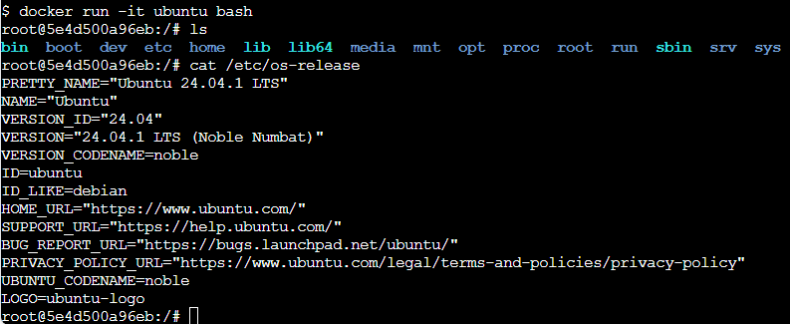

root@4e2b259b98d4:/# uname -r
4.4.0-210-generic
root@4e2b259b98d4:/# exit
exit
[node1] (local) root@192.168.0.28 ~
$ uname -r

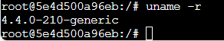

$ docker run -it ubuntu bash

root@76b850c491b5:/# find /bin /usr/bin /sbin -type f -executable

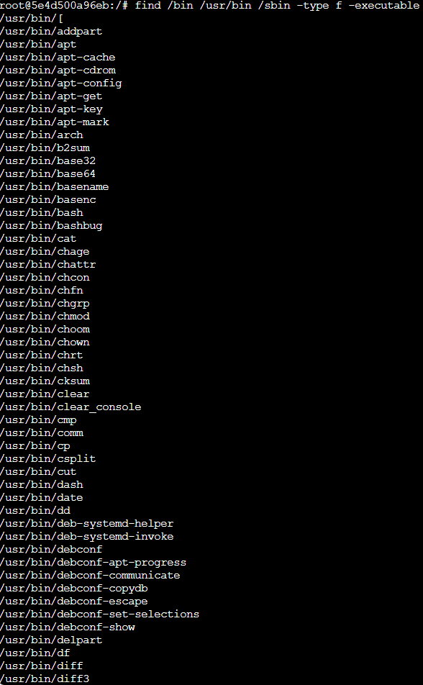

root@76b850c491b5:/# ls /lib /usr/lib

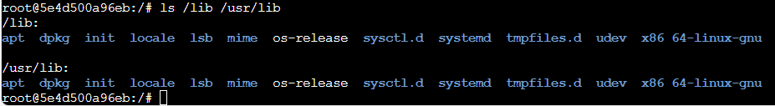

$ docker run -it mysql bash

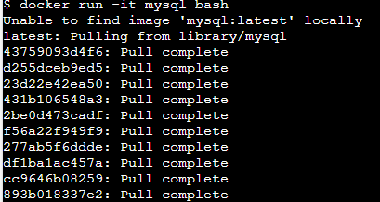

bash-5.1# uname -r
bash-5.1# cat /etc/os-release

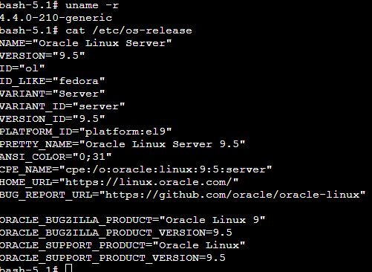

$ apk add strace
$ docker ps
CONTAINER ID IMAGE COMMAND CREATED STATUS PORTS NAMES
7d4981274c9e ubuntu "bash" 5 seconds ago Up 5 seconds sharp_chatelet
[node1] (local) root@192.168.0.28 ~

$ docker inspect --format '{{.State.Pid}}' 7d4981274c9e
978
[node1] (local) root@192.168.0.28 ~
$ sudo strace -p 978
strace: Process 978 attached
pselect6(1, [0], NULL, NULL, NULL, {sigmask=[], sigsetsize=8}

$ docker run --rm mcr.microsoft.com/dotnet/aspnet:7.0 cat /etc/os-release

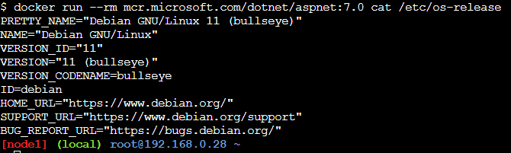

$ docker run mcr.microsoft.com/dotnet/sdk:7.0 cat /etc/os-release

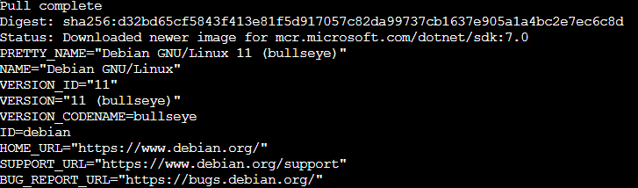

$ docker images

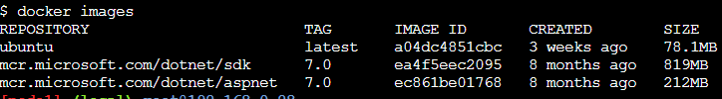

$ docker history mcr.microsoft.com/dotnet/aspnet:7.0

